# Visa PP Wholesale Automation

This process to run on 1st of every month, this involves LV Report to pull data from PPBO and load data into DI-BILLING server (rprt.VisitBySource)  
  
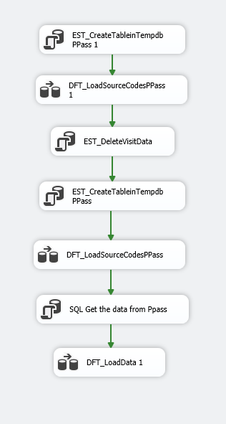

This job is scheduled to run on DI-BILLING server on 1st of every month at 7:30 AM  
  
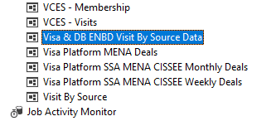

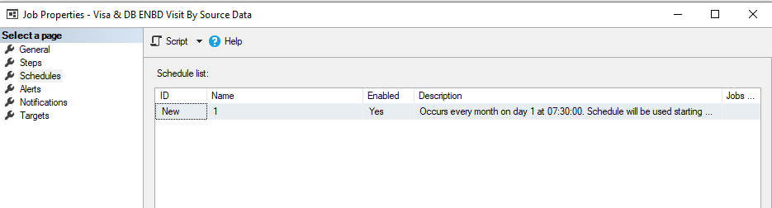

Next step to run Alteryx Job which is scheduled to run at 9 AM on 1st day of month





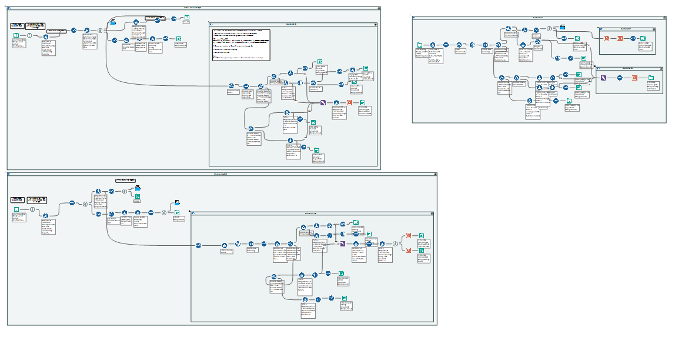

Output files directly generate on below location  
  
\\clbnas01\PriorityPass\8A. OPS VISA WHOLESALE LITE\Monthly Reports\2023\1. Jan 23\Automation